Modular Framework:

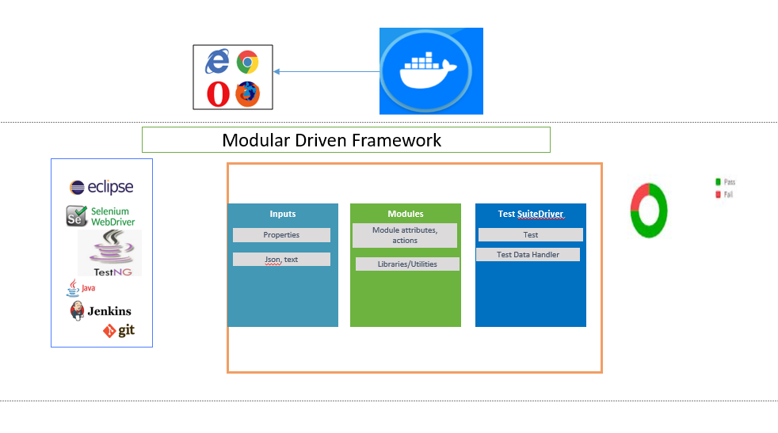

Input Data: Handled through Properties/Text Files

Modules: Captures Attributes and actions for every feature/module present on the UI

Tests: Tests are derived through DE parameterization of modules with input data

Running Tests:

Modules are compiled and packaged in jar

Command to Run:

java -cp todocrudselenium-docker.jar:todocrudselenium-docker-tests.jar:libs/\* -DBROWSER=$BROWSER org.testng.TestNG testng.xml

Parallel Execution:

Achieved thorugh Docker by creating multiple containers with different platform configuration on demand.

Command to run:

docker-compose up | grep -e 'search-module.xml'

Reporting:

TestNG report along with Extent report with more detailed view on graphical representation is derived.

Jenkins Pipeline:

Scripted pipeline is built to Create image, pull, push image and finally to run the image on containers to run the UI tests parallel in the containers created on demand.